Name _____________________
Test date _____________________

Plant Study Guide
Describe the process of photosynthesis. Include these words in your explanation: carbon dioxide, oxygen, chlorophyll, glucose, energy. Remember to include what the stem, leaves and roots do during photosynthesis.

Words you must include:
- Carbon dioxide
- Oxygen
- Chlorophyll
- Glucose
- Energy/Light
- Stem
- Leaves
- Roots

Draw a picture/diagram to show the process of photosynthesis in a flower. Your picture should match your explanation from above.

What are the four needs of a plant?

Name all the ways seeds can be spread.

Describe the two types of roots.

Describe the life cycle of a plant. You may draw pictures but please label the pictures.

Label the parts of the flower and describe the functions (what it does) of each part.

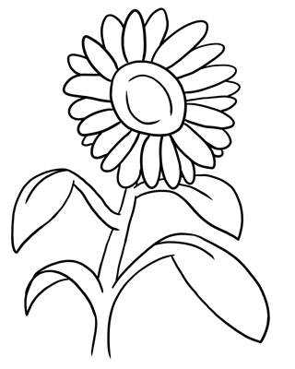
Include:
- Leaves
- Roots
- Stem
- Stomata
- Flower

What does the Xylem and Phloem do? Where are they located?

What does chloroplast do? Where is it located?

What are spores?

How are spores carried?

How do spores become plants? Describe the process.

